**Beverage Vending Machine**

1. **Introduction**

In today’s Vending Machine industry one of the most vexing challenges for anyone who vending machines is knowing when there’s a glitch. Likewise, nothing is more aggravating customers and admin users when vending machines eat the customer’s money whenever some available products runs out. In some cases, some modern vending machines indicate whether that product is out of stock, hence it doesn’t indicate the quantity of the beverage that the customer will select. For this scenario the user might enter a greater quantity than the available stock which leads to unexpected glitch to the vending machine. Through this Vending Machine Simulator system, both admin and customer can experience a user-friendly procedure when using a vending machine which gives more information to customers about the quantity of available products. Admin can add items that are not yet added to the roster of beverages or delete items that our not currently in stock. Customers can order beverages by quantity and input the amount of cash for change. This system contributed to fundamental changes in the structure of the industry. The system will help vending machines avoid these kinds of glitches that are mentioned using a window application.

1. **Objectives**

The objectives of this system are:

1. To help both admin and customers in avoiding hitch, or trouble in using the vending machine.
2. To implement the vending machine simulation system to the best satisfaction of the customer
3. Use database My SQLite to facilitate this process
4. **Features**
5. Start-up/Home Page

* The admin can log-in using correct username and password
* Vending button for to direct customers to the vending page

1. Admin Log-in Page

* The admin can view the beverages available – beverage id, name, quantity, price
* Add button allows admin to beverages in the list
* Delete button allows admin to delete unavailable beverages
* Edit button allows admin to edit the details of the beverages in the list

1. Add Button / to add beverage to the list

* The admin inputs the name of the beverage, quantity, and unit price
* Clicking the add button immediately adds the beverage and its details in the list
* The program prompts the admin that the item is added

1. Delete Button / to delete unavailable beverage from the list

* The program allows the admin to delete unavailable beverages by clicking on the desired beverage and clicking the delete button
* Clicking the delete button immediately deletes the beverage from the list
* The program prompts the admin that the item is deleted

1. Edit Button / to edit the information of the beverage from the list

* The program allows the admin to edit the information of the beverage by clicking on the desired beverage and editing the details in the text box
* Clicking the edit button edits the details of the beverage, and immediately updates the list
* The program prompts the admin that the item is edited

1. Customer Vending Page

* The program displays available beverages – beverage id, name, quantity, price
* The customer needs to input only the beverage id, and the amount of money to be paid
* The program prompts the customer that vending is successful
* The program will also display amount of change, if any.

1. **Architectural Design**

The architectural design of Beverage Vending Machine is based on the three-tier architecture. These predominantly composed of three layers specifically:

* Presentation Layer
* Business Layer
* Data Access Layer

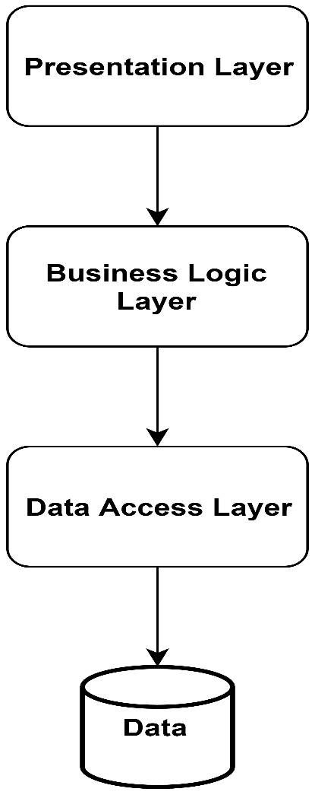

Architectural Design consists of three logical layers.  The presentation layer is what a system user sees or interacts with.  It can consist of visual objects such as screens, web pages or reports or non-visual objects such as an interactive voice response interface. The business logic layer, on the other hand, represents the business rules of the vending machine that are enforced via programming logic regarding how those rules are applied. The data access layer consists of the definitions of database tables and columns and the computer logic that is needed to navigate the database.  The data access layer enforces rules regarding the storage and access of information. For example: prices must be valid prices and numeric fields must never contain alphanumeric characters.

1. **Graphical User Interface**

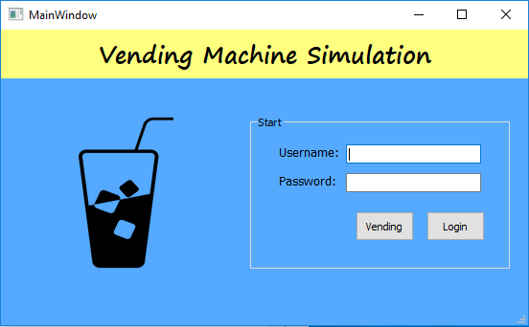

Figure 1. Admin Login page

The figure above shows the user interface for the admin login page, the admin needs to enter the username and password to access the database of the machine. The vending button is for the customers to directly undergo the buying process.

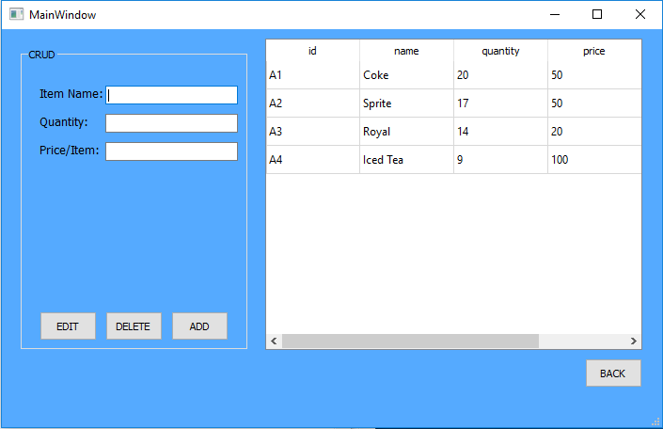

Figure 1a. Main Window after login

The figure above shows the main window after the admin has logged in. The admin can see the beverages available, he can also add beverages, delete the beverage if it is not available and edit the price of the beverage.

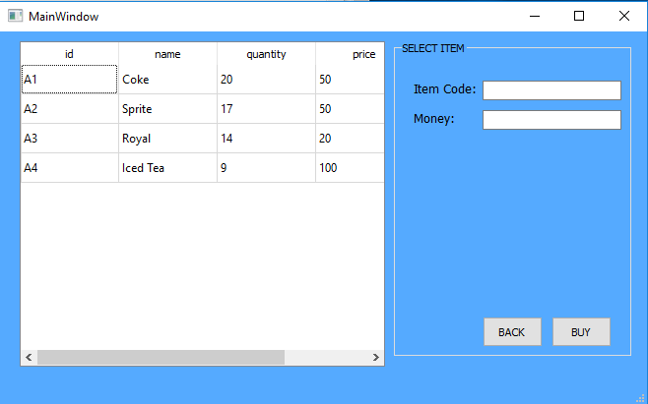

Figure 1b. Main window for the buying process

The figure above shows the buying process of the customer after clicking the vending button in the homepage. The customer has the option to choose from different beverages that are available. The customer will only enter the item code of the desired beverage and the amount of money.

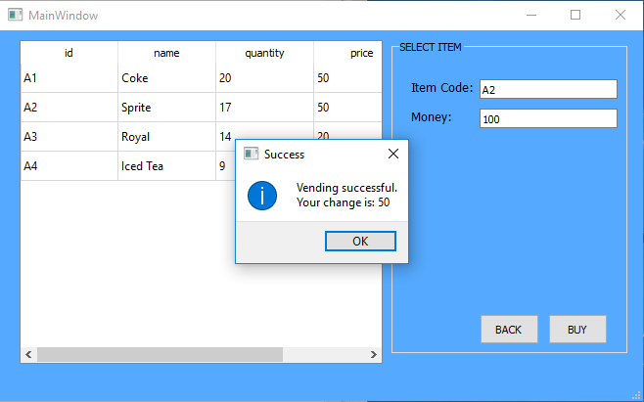

Figure 1c. Vending successful

The figure above shows the result after the customer has entered the item code and amount of money of the desired beverage. There is a prompt that says that the vending is successful, a change is given if the amount inserted in the machine is greater that the price of the beverage. Also, the number of the beverage in stock decreases when someone buys it.

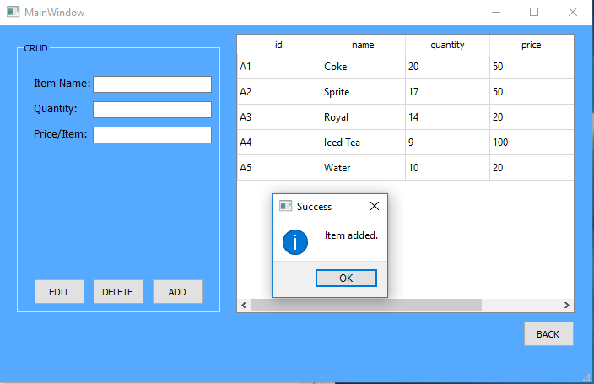

Figure 1d. Add Beverage

The figure above shows the process of adding a beverage. The admin enters the item name, quantity and the price of the item. In this case, water is added to the list of the beverages available in the machine.

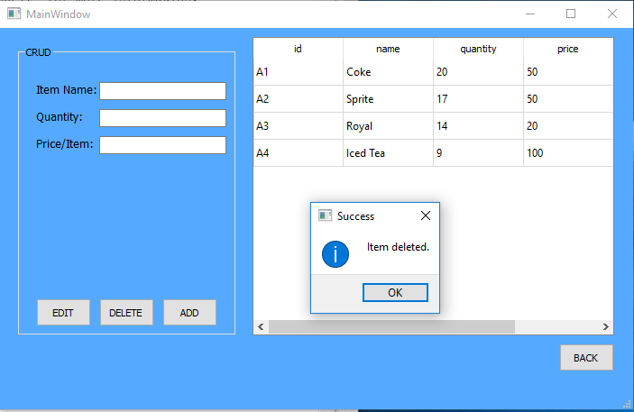Figure 1e. Delete non-existing item

The figure above shows the removing of the product from the list if there is no available stock inside the machine.

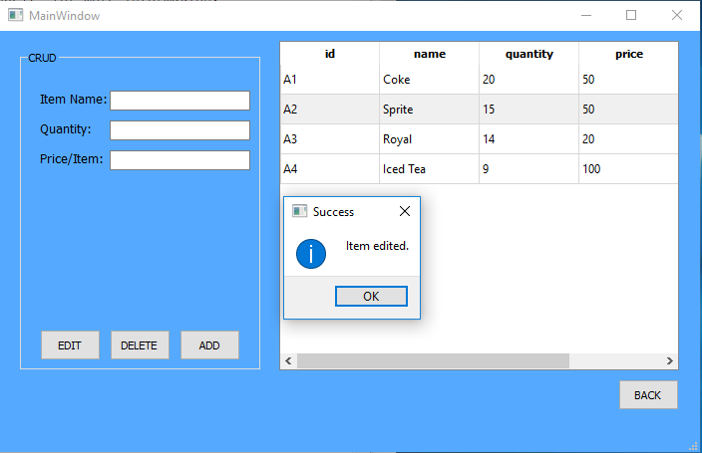

Figure 1e. Edit item

The figure above shows the modifying of the item name, the number of quantity available and the price of the item.

1. **Use Case Diagram**

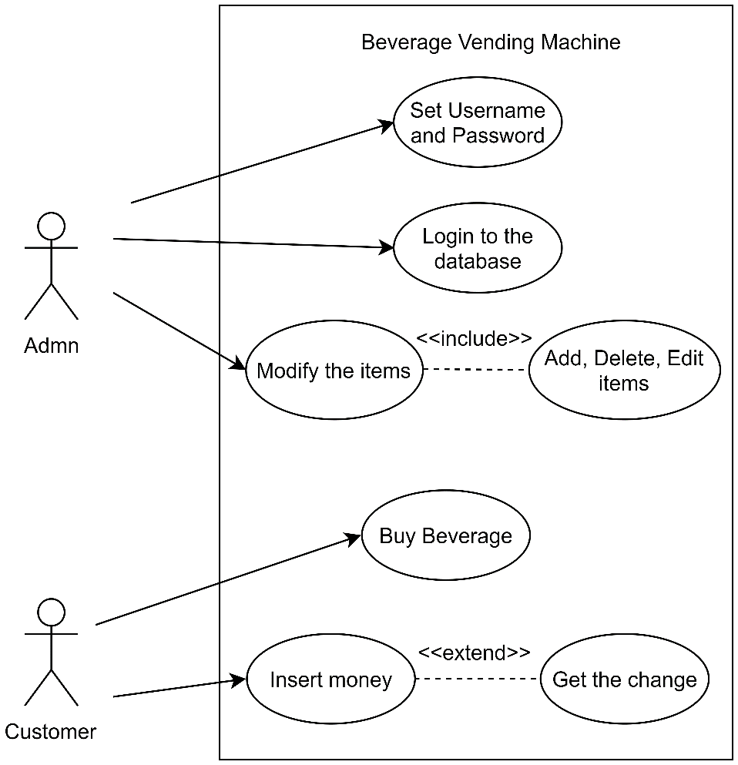

The figure above shows the use case diagram of the system. There are two actors which is composed of admin and the customer. The admin is the one who sets the username and password and the one that has access to the database of the vending machine. The admin can also modify the items in the vending machine, he can add the number of beverages in stock, delete items that are not available and edit items by changing the number of quantity and price of the item. The customer on the other hand is the one who buys the beverage. The customer is the one who inserts money in the machine for it to process. The change is handed over if the amount inserted is greater than the price of the beverage.

1. **Use Case Specifications**

|  |  |
| --- | --- |
| Name | Admin login |
| Actor | Admin |
| Description | Permits the admin to login and access the database. |
| Pre-condition | Only admins are required to login |
| Post-condition | The admin can view the available items in the vending machine. He can also modify items in the vending machine. |
| Flow of events | 1. Admin enters “username” and “password”. 2. Click “Login” button. 3. The admin views the beverages available and modify price of the item. |
| Alternative flow | None |

|  |  |
| --- | --- |
| Name | Add item |
| Actor | Admin |
| Description | Permits the admin to add items in the list of available beverages. |
| Pre-condition | Only admins are required to add items. |
| Post-condition | The admin can view the list of added items. |
| Flow of events | 1. Admin enters “item name” 2. Admin enters “quantity” 3. Admin enters “price” 4. Admin selects “add” button |
| Alternative flow | None |

|  |  |
| --- | --- |
| Name | Delete item |
| Actor | Admin |
| Description | Permits the admin to delete items that are not available for customers. |
| Pre-condition | Only admins are required to delete items. |
| Post-condition | The item is removed from the list. |
| Flow of events | 1. Admin selects the row of the item which is not available. 2. Admin selects “delete” button. |
| Alternative flow | None |

|  |  |
| --- | --- |
| Name | Edit item |
| Actor | Admin |
| Description | Permits the admin to edit items such as the item code, number of available and the price of the said item. |
| Pre-condition | Only admins are required to edit items. |
| Post-condition | The new item code, number of quantity and price is shown in the list. |
| Flow of events | 1. Admin selects the row of item to be edited. 2. Admin enters new “item code”. 3. Admin enters new “quantity”. 4. Admin enters new “price”. 5. Admin selects the “edit” button. |
| Alternative flow | None |

|  |  |
| --- | --- |
| Name | Buying process |
| Actor | Customer |
| Description | The customer buys a beverage in the vending machine. |
| Pre-condition | Customer will choose his/her desired drink in the vending machine. |
| Post-condition | The beverage is being dispatched and ready to be picked up by the customer. |
| Flow of events | 1. Customer selects an available beverage in stock. 2. Customer inserts money in the machine. 3. Machine dispatches the beverage. 4. Machine dispatches change if there is any. |
| Alternative flow | None. |

1. **Class Diagram**

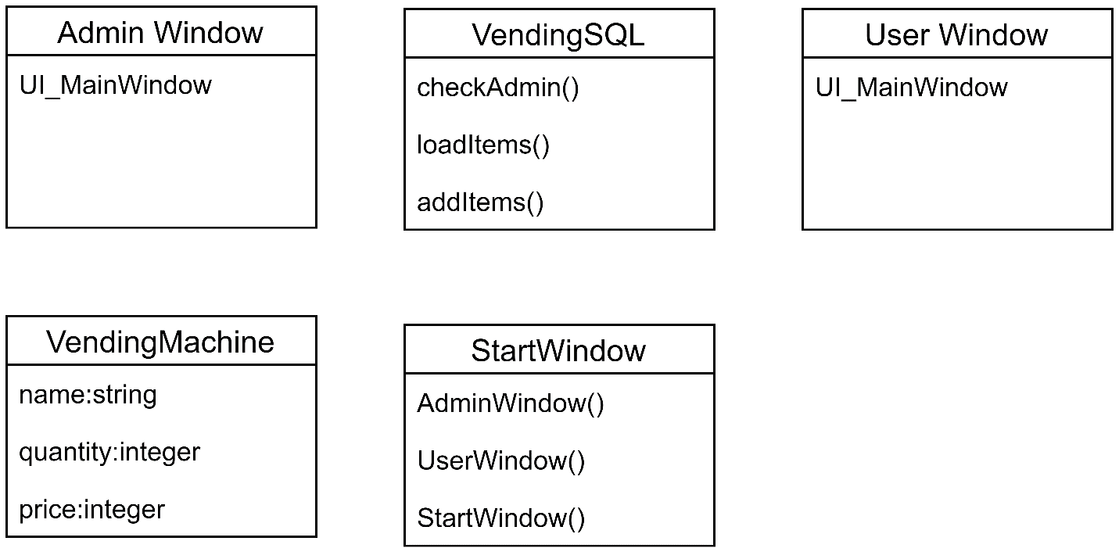

1. **Test Case**

|  |  |  |  |  |  |  |
| --- | --- | --- | --- | --- | --- | --- |
| Test Case # | Function | | Event | | Expected Output | Actual Output |
| 1 | Admin Login | | Enter correct username and password | | Proceed to main window. View available items/products. | Main window |
|  |  | | Entered incorrect username and password | | Prompt shows that the username and password entered is invalid. | Message box |
| 2 | Add item | | Enter item name, quantity and price | | The new item is now included in the list of available items. | List of items |
|  |  | | Entered invalid input in the field. | | Prompt shows that item name must be alphanumeric only and quantity and price must be integer. | Message box |
| 3 | Delete item | | Select row to delete. | | Prompt shows that the item is deleted successfully. | Message box |
| 4 | Edit Item | | Select row to edit. | | Prompt shows that the item is edited successfully. | Message box |
| 5 | Buy item | Enter item code and amount to be inserted. | | | Prompt shows that vending is successful and gives back change if there is any. | Message box |
|  |  | Invalid amount inserted. | | Prompt shows that the valid paper money amounts are 20, 50 and 100 only. | | Message box |

1. **Recommendation**

In the future, other groups can stretch the functionality of the program, and not limiting it to how the program was designed by the group. They can add more features, upgrade the user-interface, and improve user-experience. They can also try to user other programming language, and other database depending on the client requirements.

1. **Conclusion**

The group was successful in producing a program – the Vending Machine Simulation – which incorporates the use of MySQL database to facilitate the processes in the program, while running it using the python environment. The group was able to make a program that does it purpose well, and in accordance to the client needs and requirements.